

Netspective Communications
May 13, 2026
Opsfolio
Lead Magnets Tour

Table of Contents
Opsfolio Lead Magnets Tour 2
Overview 2
1. Customer Journey Overview 3
Typical Lead Journey 3
2. Landing Pages & Campaign Experience 3
Example Public Landing Pages 3
Opsfolio – Self-Assessment Malyszek 3
Self-Assessment Malyszek – Readiness Score Experience 3
Landing Page Goals 4
3. Sign-Up & User Inputs 4
Initial Sign-Up Information 4
4. Assessment Experience 1
CMMC Assessments 1
SOC 2 Readiness Assessments 2
5. Automated Emails & Customer Touchpoints 2
Automated Customer Experience 2
6. Reports & Outputs Generated 4
CMMC Level 1 Reports 4
SOC 2 Readiness Reports 5
7. How Channel Partners Can Use the System 5
Partner-Driven Campaigns 5
Why This Matters for Partners 5
8. Example Funnel Progression 6
Awareness Stage 6
Engagement Stage 6
Evaluation Stage 6
Follow-Up Stage 6
9. Current Capabilities 7
10. Business Value 7
Final Summary 8

Opsfolio Lead Magnets Tour
This document is intended for marketing agencies, channel partners, prospective partners, sales enablement teams, and external GTM collaborators. It covers what currently works: the customer-facing assessment journey, landing pages, reports users receive, email touchpoints, and how partners can use the system. For internal operational details, automation architecture, and roadmap planning, refer to the companion internal document.

Overview
Opsfolio’s CMMC and SOC 2 compliance readiness tools are designed to reduce friction and enable self-assessment, helping organizations evaluate their cybersecurity and compliance posture through guided Readiness Assessments and Self-Assessments.
These workflows are intentionally designed to:
- Reduce friction during initial engagement and enable self-service assessment
- Help prospects understand their current readiness position
- Generate immediate value through automated self-assessment reports
- Enable channel partners to engage prospects at scale
- Create structured follow-up opportunities for consulting and remediation services
These tools function as a customer-facing compliance engagement experience, currently focused on Readiness Assessments and Self-Assessments, combining:
- Landing pages
- Guided assessments
- Automated report generation
- Email touchpoints
- Readiness scoring
- Partner-branded engagement workflows

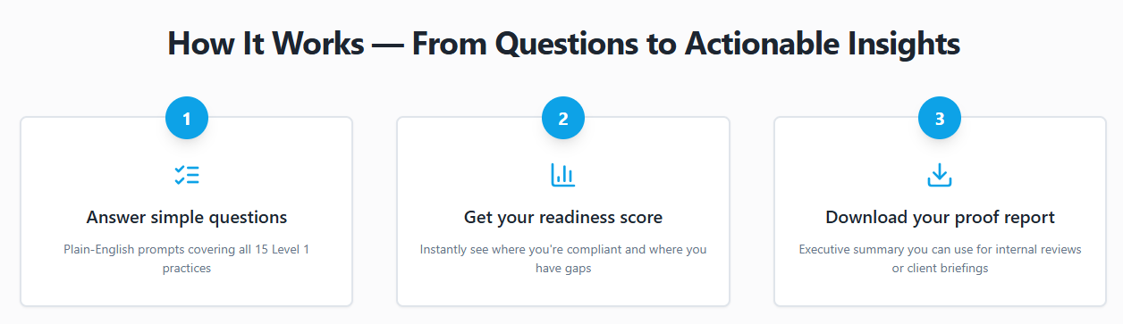

1. Customer Journey Overview

Typical Lead Journey
- Prospect receives a campaign link or visits a landing page
- Prospect signs up using a simple form
- Prospect starts the compliance readiness assessment
- Assessment questions guide the user through their current compliance posture
- Readiness calculations are performed automatically
- A report or readiness summary is generated
- Follow-up conversations can be initiated by the partner
- Customer progresses toward remediation and compliance engagement
The process is designed to feel lightweight, guided, and self-service.

2. Landing Pages & Campaign Experience

Example Public Landing Pages

Opsfolio – CMMC Level 1 Self-Assessment
https://opsfolio.com/regime/cmmc/self-assessment-landing/

Opsfolio – Self-Assessment Malyszek
https://opsfolio.com/lp/cmmc/self-assess-malyszek/
https://opsfolio.com/lp/cmmc/self-assess-malscmmc/
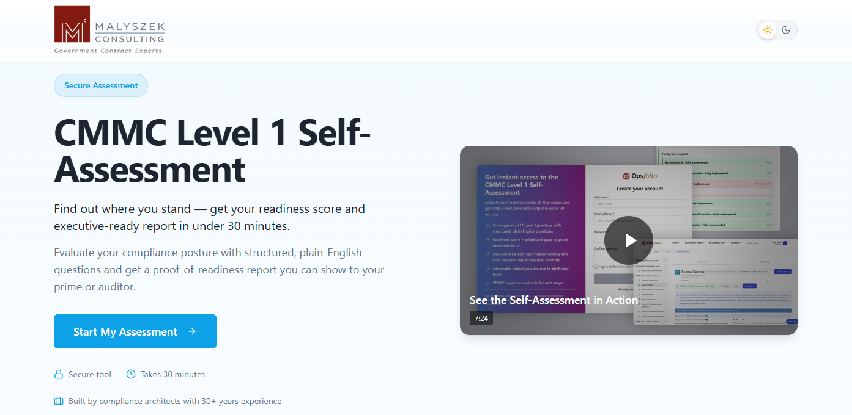

Landing Page Goals

The landing pages are designed to:
- Introduce compliance-readiness assessments
- Explain the business value of self-assessment
- Encourage immediate engagement
- Capture prospect information
- Guide users toward assessment completion
Typical landing page elements include:
- Compliance overview
- Business-risk positioning
- Readiness messaging
- Assessment entry points
- Call-to-action buttons
- Lead capture forms
- Partner branding

3. Sign-Up & User Inputs
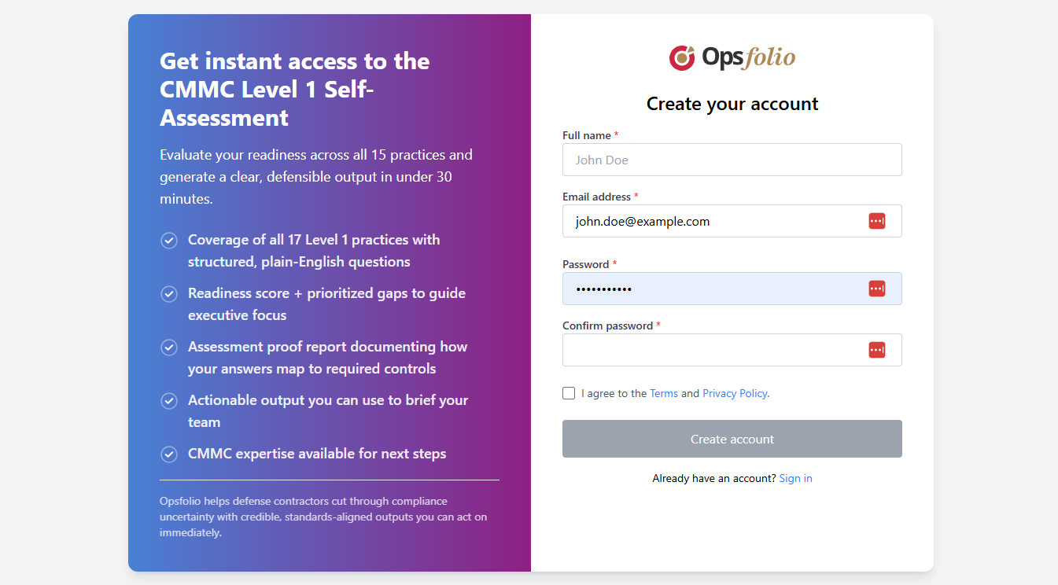

Initial Sign-Up Information

The current workflows typically collect:
- First Name
- Last Name
- Email Address
Additional information may be collected throughout the assessment process depending on the workflow.

4. Assessment Experience

CMMC Assessments
The CMMC Self-Assessment walks users through a structured series of questions covering their current security practices. The experience is guided and self-service, covering areas such as:
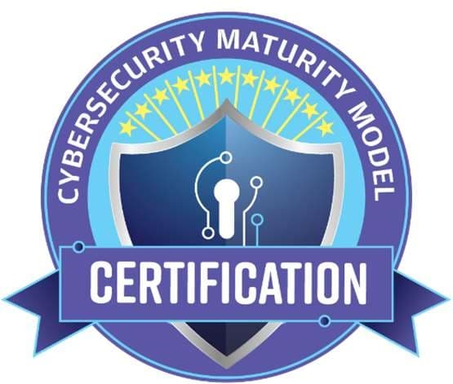
- Questions to determine the applicable CMMC level
- Current security practices and controls
- Existing policies and documented processes
- How access to systems and data is managed
- Incident response and recovery preparedness
- Risk management and vendor oversight practices
- Documentation and day-to-day operational practices
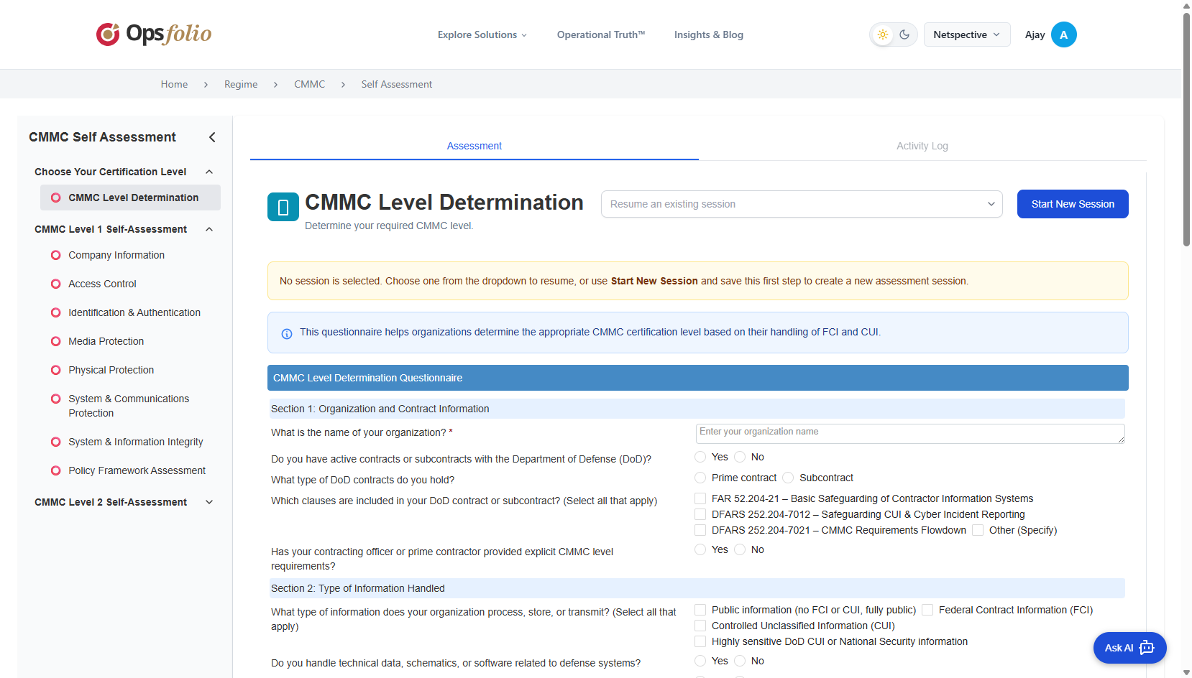
At the end of the assessment, users receive a clear picture of:
- Where they likely stand against CMMC requirements
- Specific areas that need attention before certification
- A starting point for remediation conversations

SOC 2 Readiness Assessments
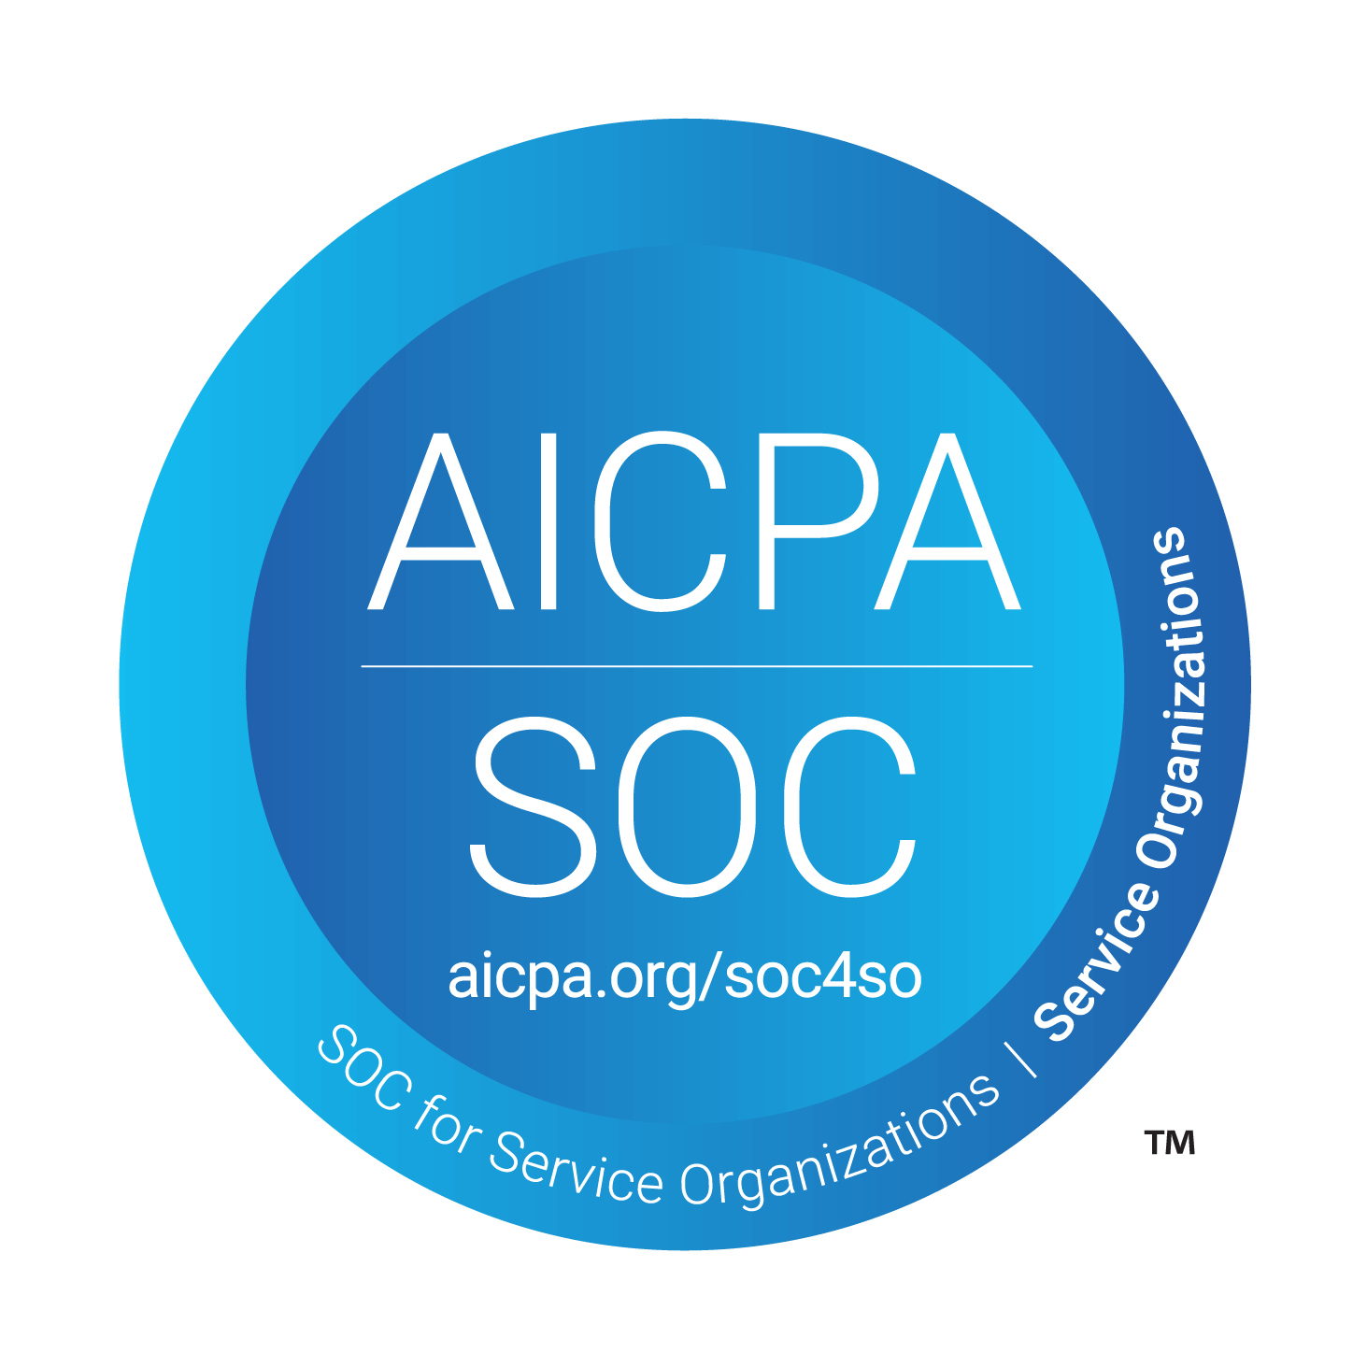
The SOC 2 Self-Assessment guides users through a structured review of their operational and security practices. It covers areas such as:
- How security governance and oversight is structured
- Operational controls currently in place
- Readiness for an external SOC 2 audit
- Availability of evidence and supporting documentation
- User access management and identity practices
- Monitoring, logging, and operational procedures
The completed assessment gives organizations a practical, directional view of where they stand and what to address before pursuing a SOC 2 audit.
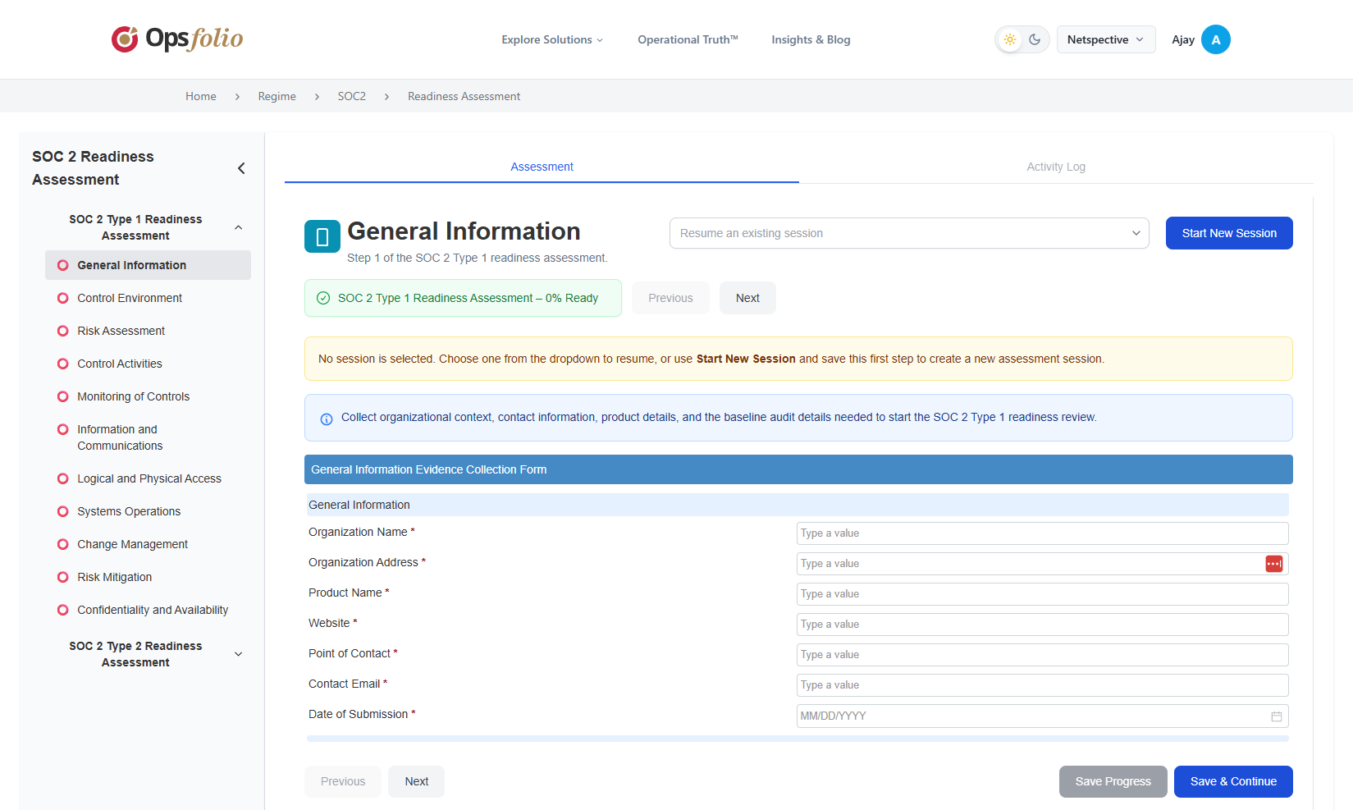

5. Automated Emails & Customer Touchpoints

Automated Customer Experience
Several workflows currently trigger automated customer-facing emails.
Examples include:
- Assessment initiation notifications
- Workflow-based email responses
- Level determination follow-up emails
- Report delivery emails
These touchpoints help maintain engagement during the assessment journey.
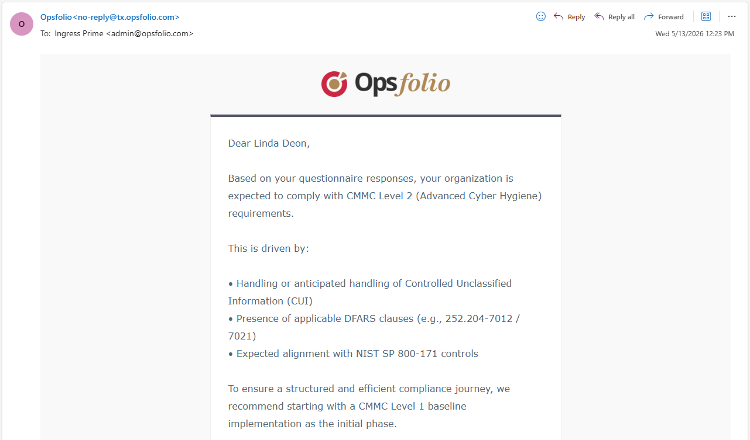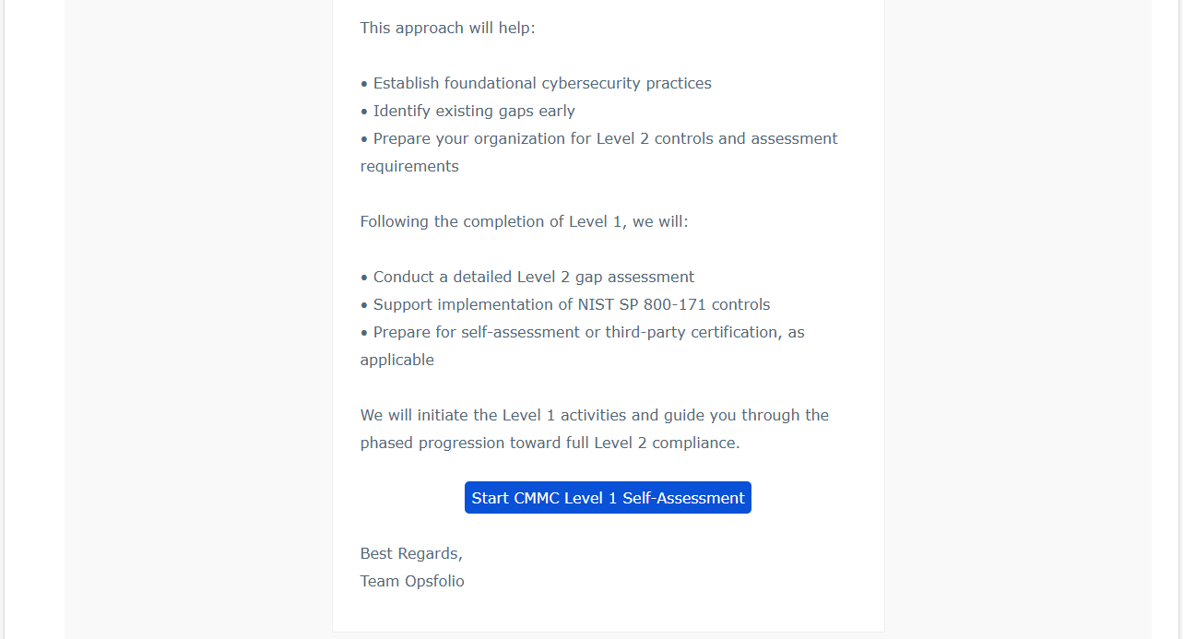

6. Reports & Outputs Generated

CMMC Level 1 Reports
Upon successful completion of the CMMC Level 1 Self-Assessment:
- A self-assessment report is automatically generated
- A report link is delivered to the user

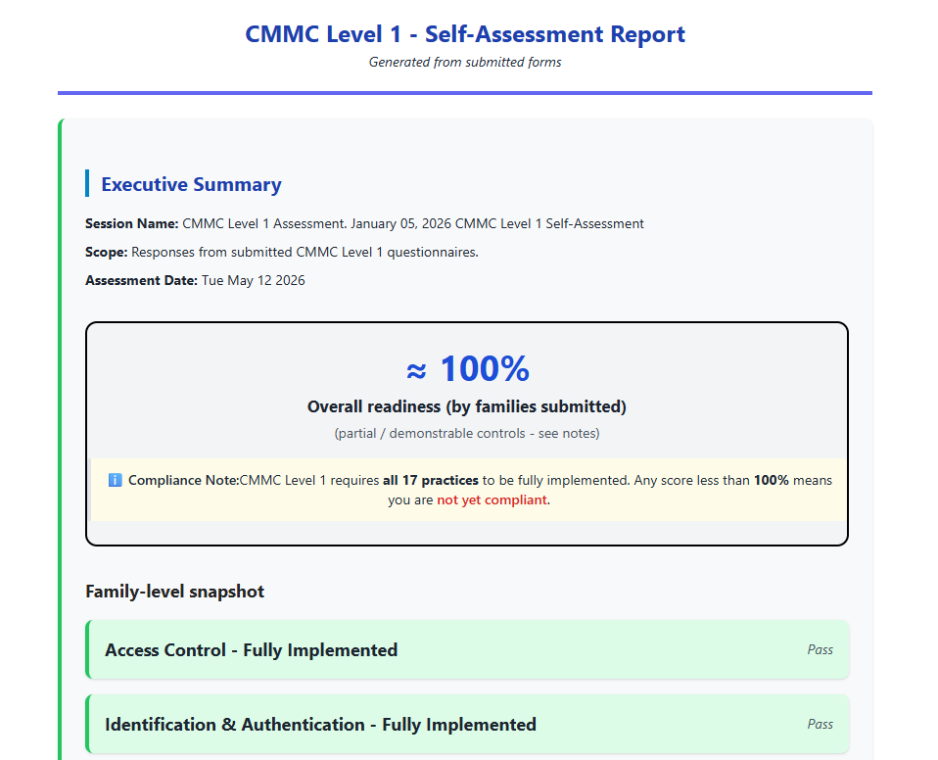
The self-assessment reports help organizations understand:
- Current readiness status
- Compliance gaps
- Areas requiring additional work
- Suggested improvement focus areas

SOC 2 Readiness Reports
SOC 2 readiness workflows generate:
- Self-assessment report summarizing readiness findings
- Gap-oriented observations
- Operational maturity indicators
- Directional compliance insights
These self-assessment reports are intended to serve as starting points for deeper readiness discussions.

7. How Channel Partners Can Use the System

Partner-Driven Campaigns
These Readiness Assessment and Self-Assessment tools are designed to support partner-led engagement models.
Channel partners can:
- Share branded campaign links
- Run outreach campaigns
- Use custom landing pages
- Receive customer engagement visibility
- Use generated reports for follow-up conversations
- Position remediation and consulting services
The Malyszek implementation is an example of this partner-driven model.

Why This Matters for Partners
The workflows help partners:
- Start conversations faster
- Reduce manual discovery effort
- Generate compliance discussions earlier
- Create consulting opportunities
- Scale outreach without large technical teams
Instead of beginning with generic cybersecurity conversations, partners can immediately discuss:
- Readiness findings
- Gap areas
- Business risks
- Improvement opportunities

8. Example Funnel Progression

Awareness Stage
Customer encounters:
- Campaign landing page
- Readiness messaging
- Compliance awareness content

Engagement Stage
Customer:
- Starts assessment
- Completes readiness questions
- Interacts with assessment workflow

Evaluation Stage
Customer receives:
- Readiness report
- Gap observations
- Compliance insights

Follow-Up Stage
Partner engages customer regarding:
- Readiness findings
- Remediation priorities
- Consulting opportunities
- Managed compliance services

9. Current Capabilities
Partners and external collaborators can count on the following being available and working today:
- Live public landing pages with campaign and partner-branded variants
- Guided CMMC and SOC 2 Self-Assessments that prospects can complete independently
- Automated self-assessment reports delivered to prospects upon completion
- Automated assessment-triggered emails keeping prospects informed at each stage
- Partner visibility into prospect engagement and assessment completion
- A self-service experience prospects can complete in under 30 minutes
Self-assessment reports available today:
- CMMC Level 1 Self-Assessment report
- SOC 2 Readiness Self-Assessment report
Coming soon:
- CMMC Level 2 Self-Assessment report

10. Business Value
These tools help transform compliance engagement from:
Traditional Manual Discovery → Guided Automated Readiness Engagement
This creates value for:
- Customers seeking quick readiness visibility
- Channel partners needing scalable outreach
- GTM teams looking for engagement acceleration
- Consulting organizations seeking qualified compliance leads

Final Summary
Opsfolio’s Readiness Assessment and Self-Assessment tools provide a structured, customer-friendly compliance engagement experience that combines:
- Readiness assessments
- Automated reporting
- Partner-led engagement
- Customer education
- Compliance awareness
- Funnel acceleration
The workflows help prospects quickly understand where they stand while giving partners and GTM teams a scalable way to initiate meaningful compliance-readiness conversations.

